Here are the output figures for my pipeline. Can you create placeholders for them in my methodology, and give me instruction on how I can add them in my README.md?

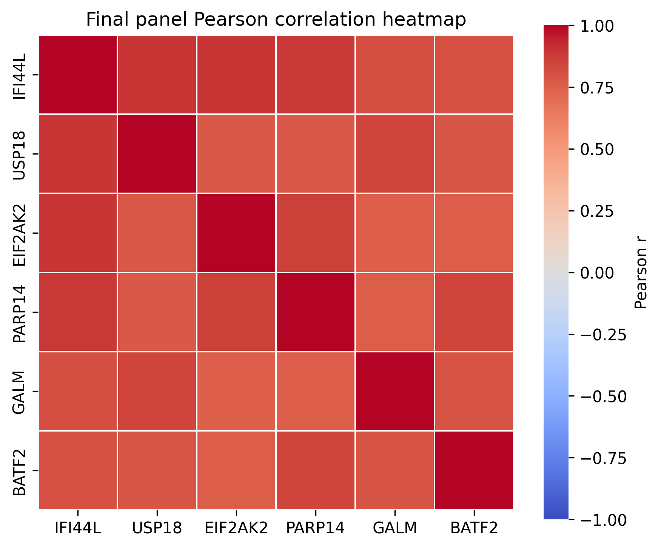
03_final_panel_correlation_heatmap.png

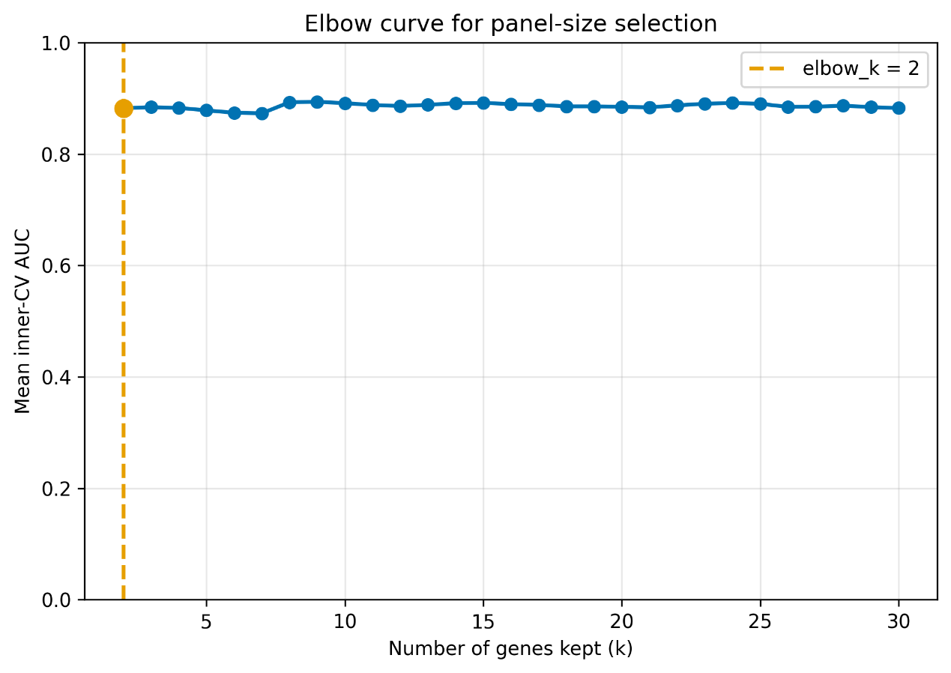
03_elbow_curve.png

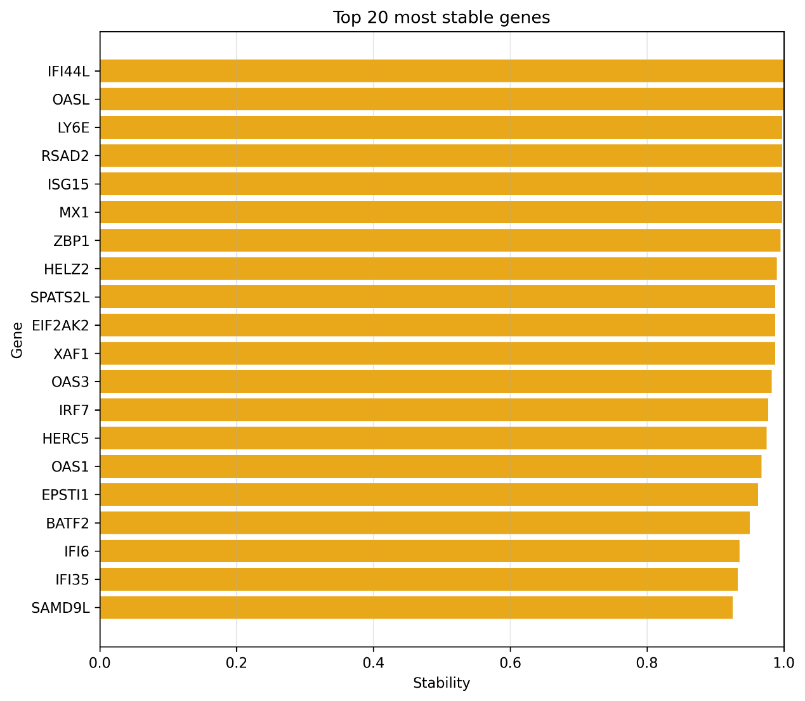
03_full_stability_top20.png

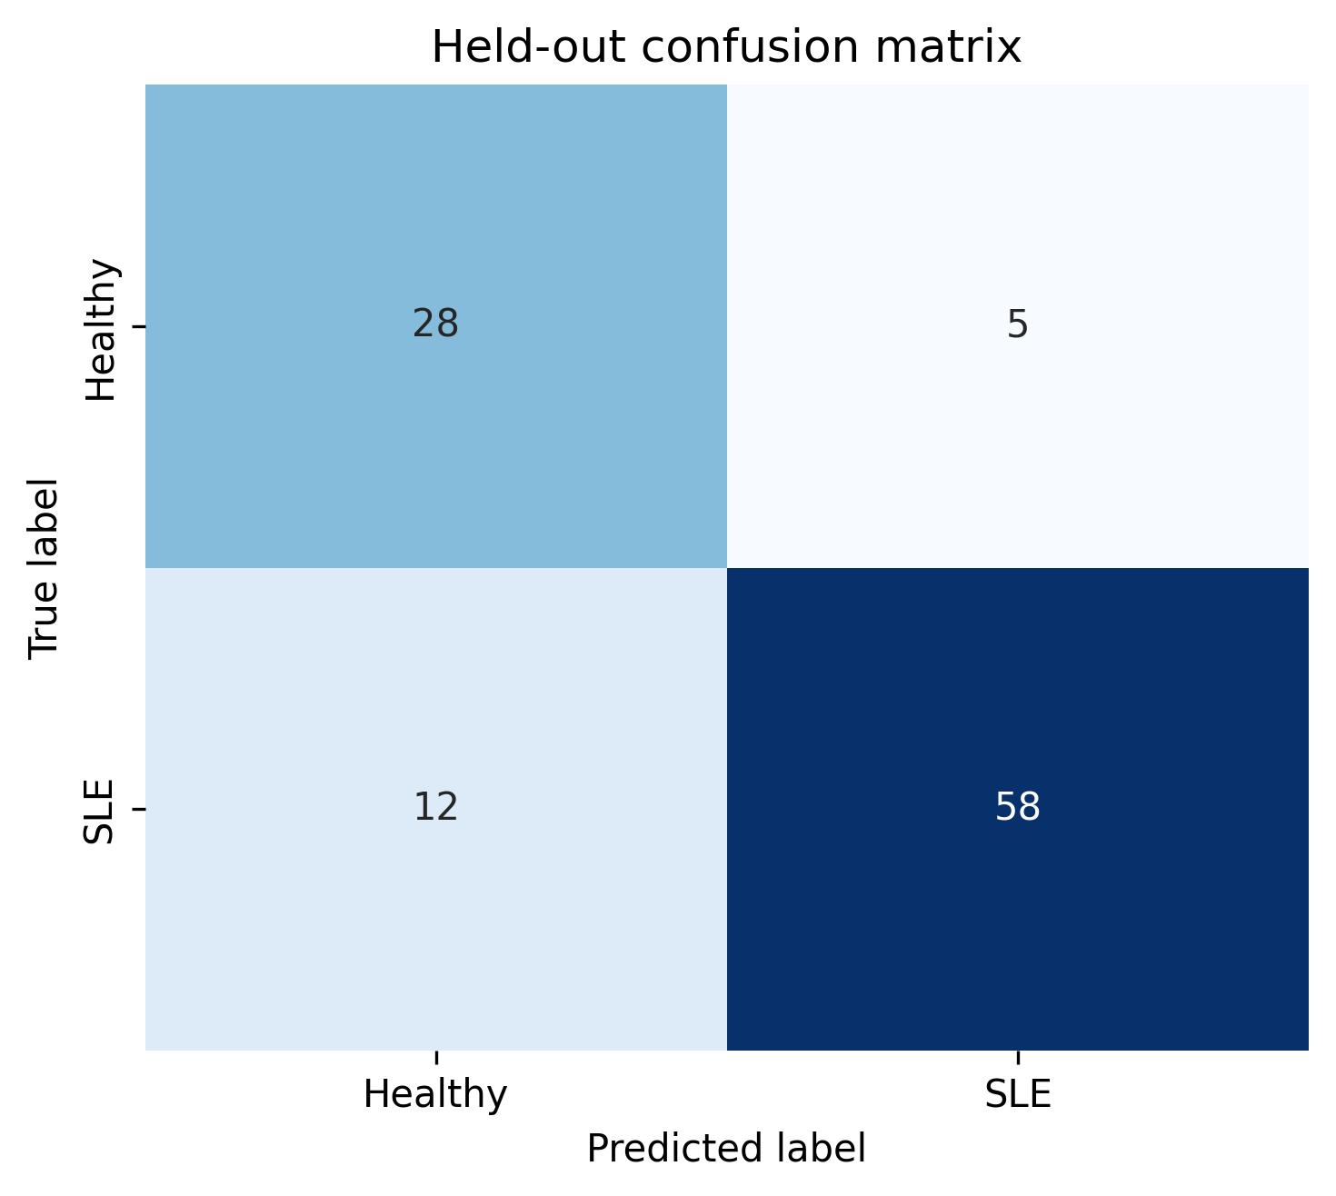
04_confusion_matrix.png

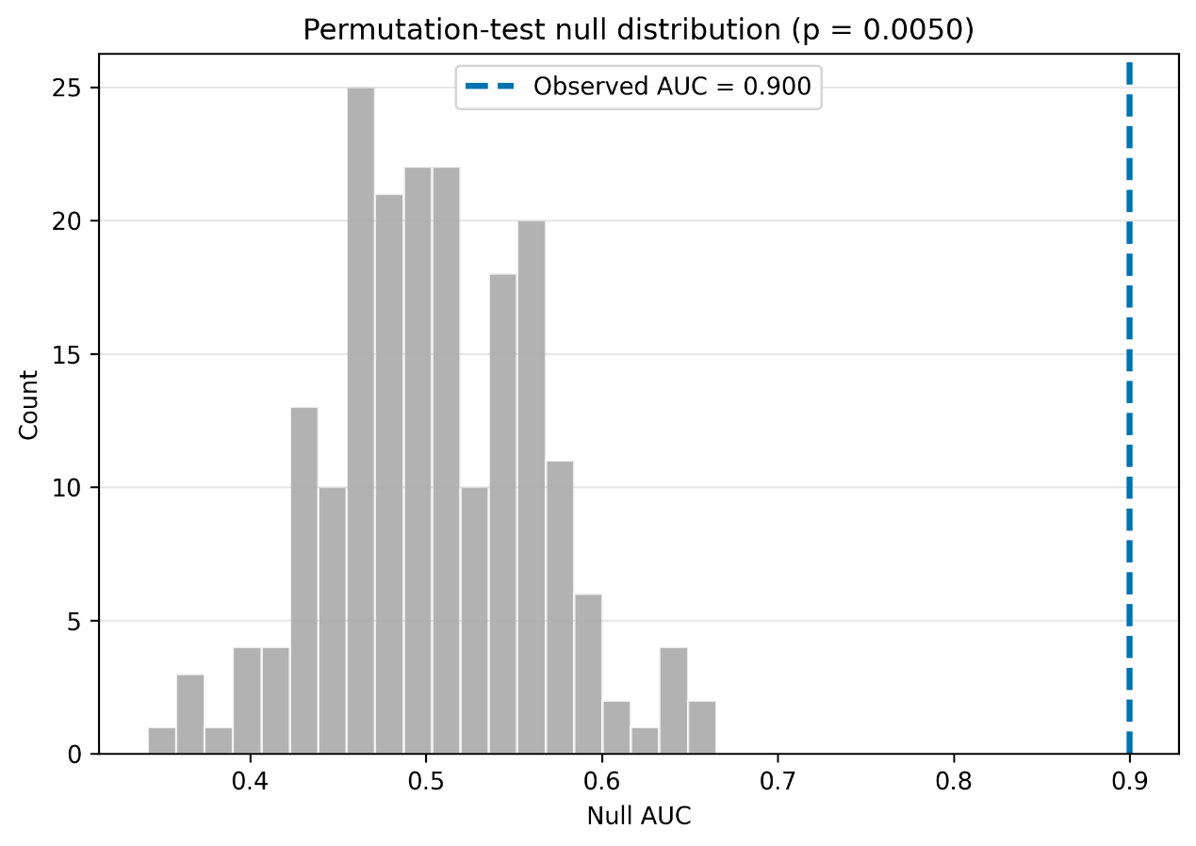
04_permutation_histogram.png

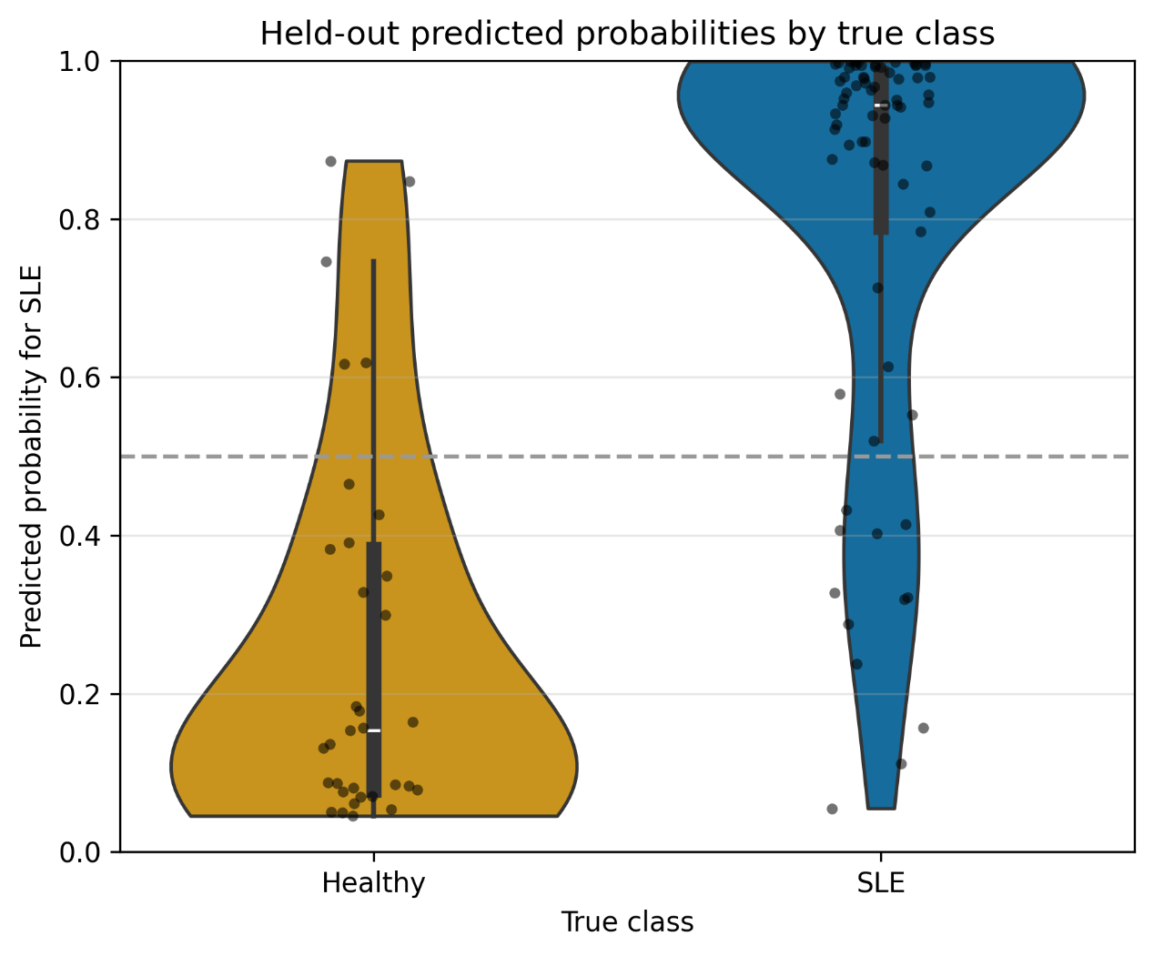
04_predicted_probability_violin.png

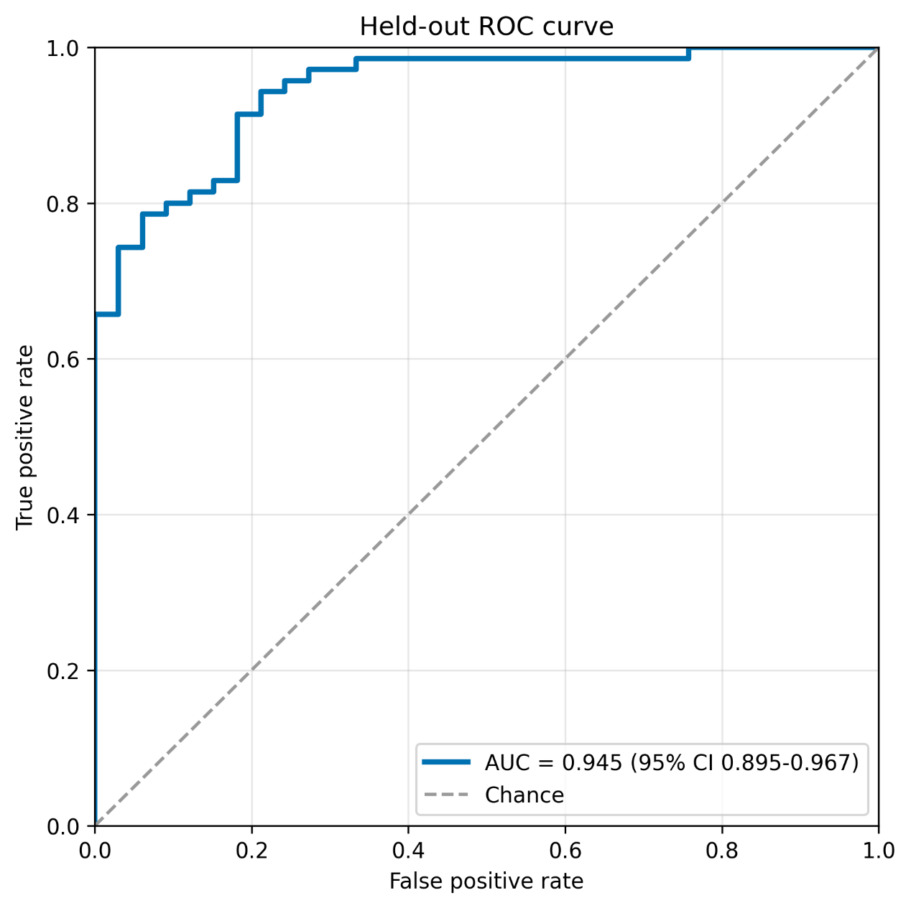
04_roc_curve.png

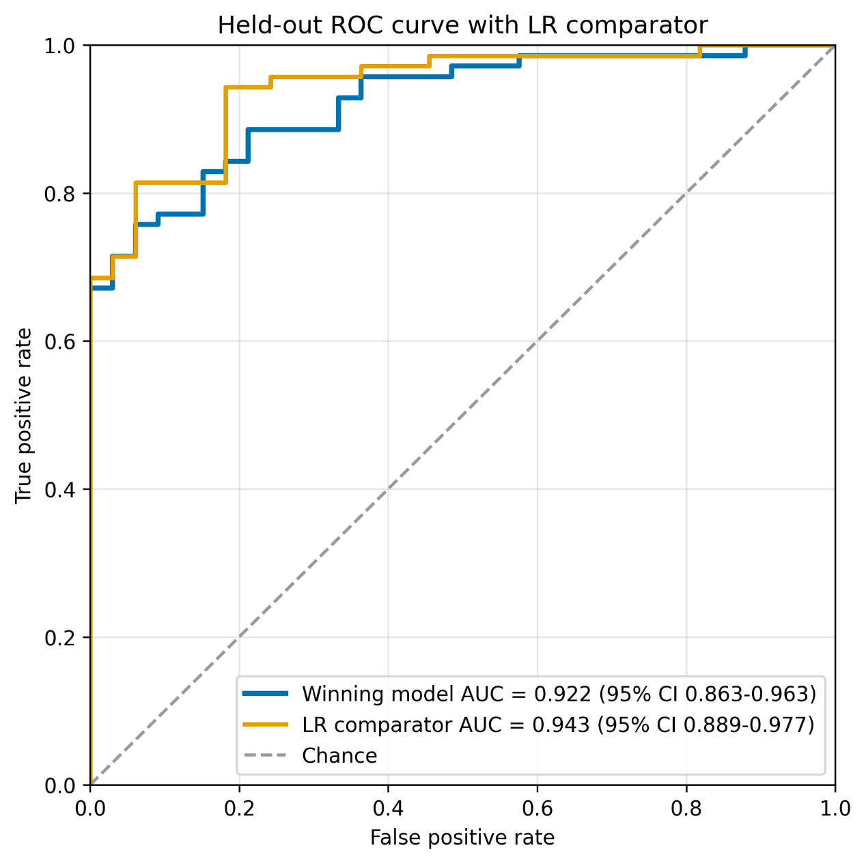
04_roc_curve_with_lr.png

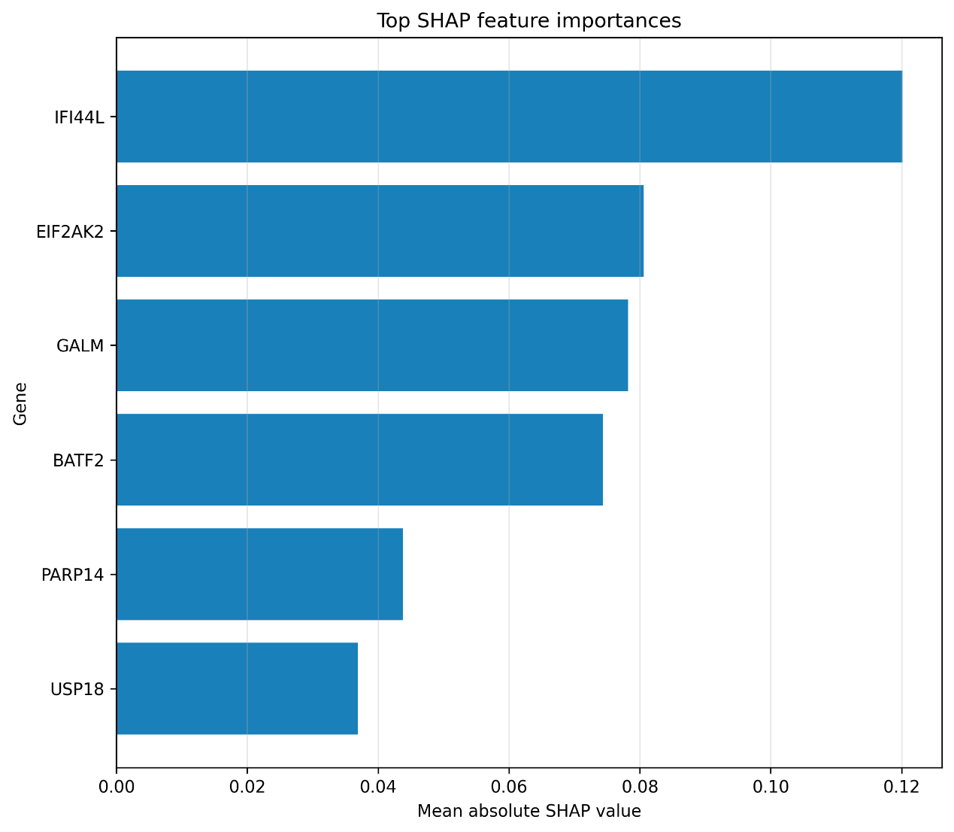
04_shap_barplot.png

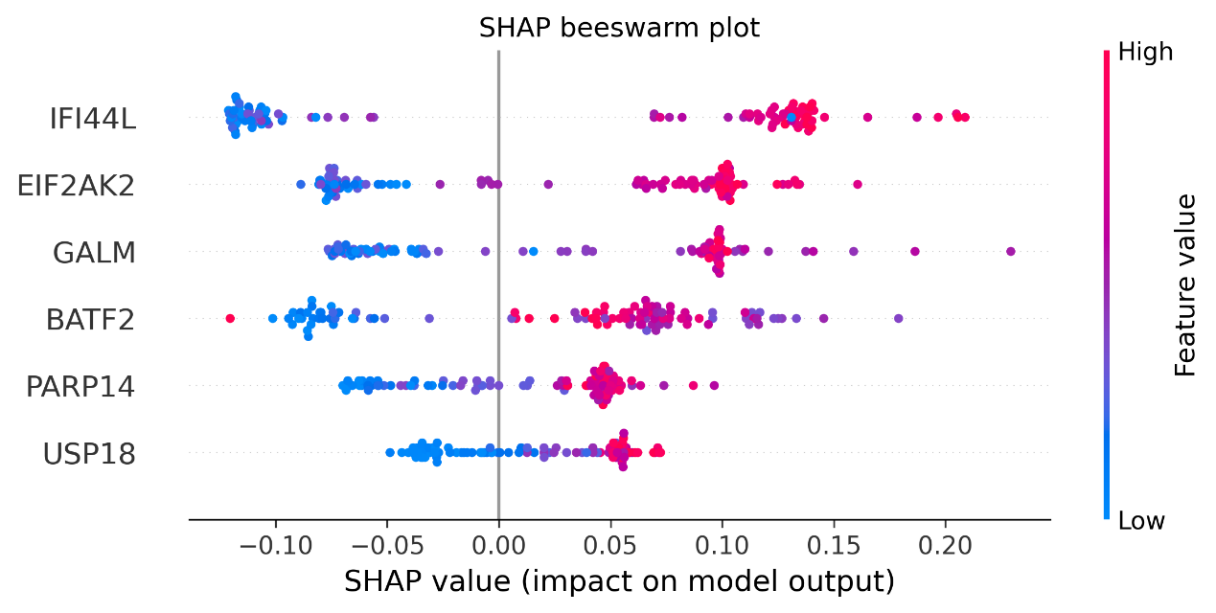
04_shap_beeswarm.png

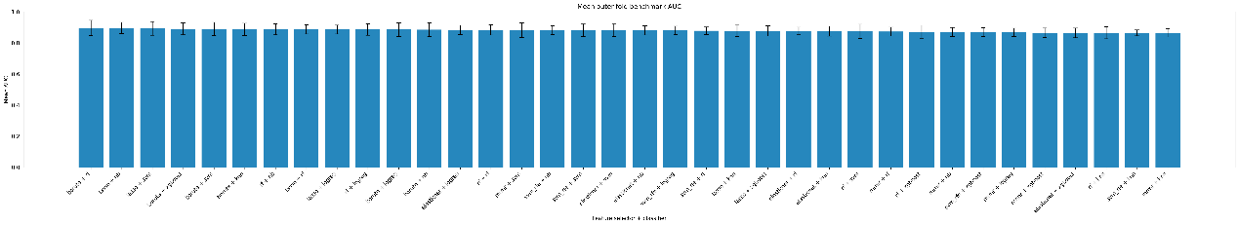
06_benchmark_barplot.png

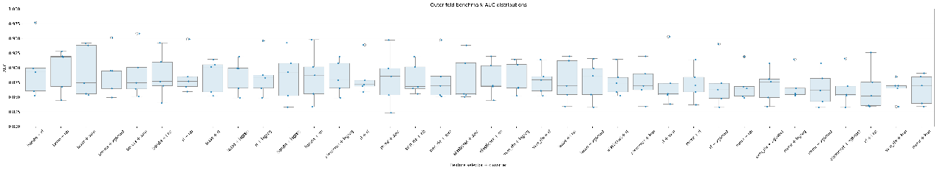
06_benchmark_boxplot.png

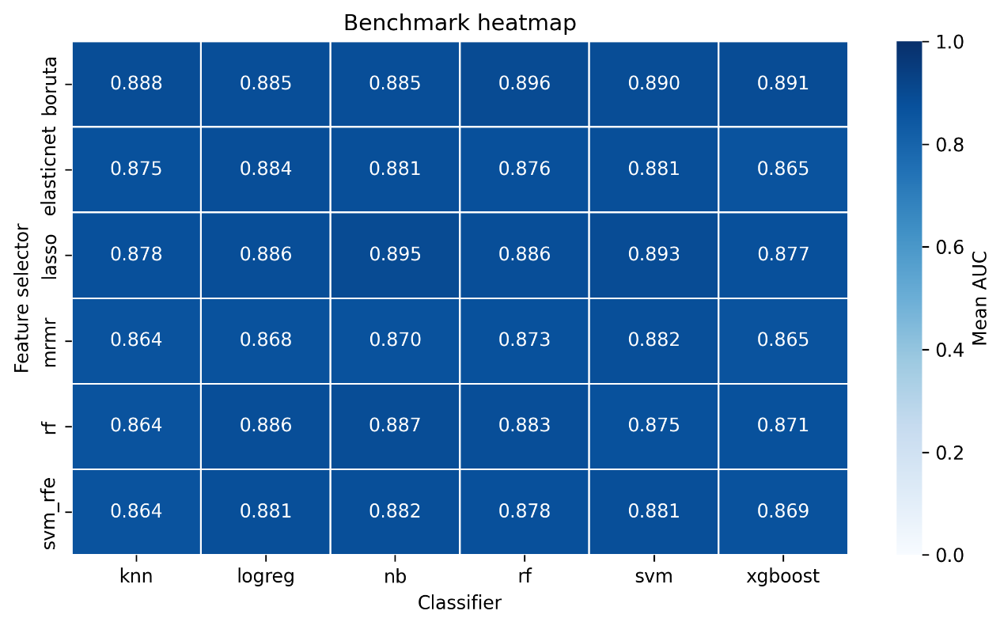
06_benchmark_heatmap.png

